AI/ML INTERN — DAY 4 TASKS

Tasks Completed
- Improved pose detection accuracy using MediaPipe and OpenCV
- Researched virtual try-on AI models
- Tested body segmentation methods
- Created clothing recommendation logic
- Compared MediaPipe vs OpenPose

1. Improved Pose Detection Accuracy
import cv2
import mediapipe as mp
mp_pose = mp.solutions.pose
pose = mp_pose.Pose(model_complexity=2)
cap = cv2.VideoCapture(0)
while True:
success, frame = cap.read()
rgb = cv2.cvtColor(frame, cv2.COLOR_BGR2RGB)
results = pose.process(rgb)
if results.pose_landmarks:
mp.solutions.drawing_utils.draw_landmarks(
frame,
results.pose_landmarks,
mp_pose.POSE_CONNECTIONS
)
cv2.imshow("Pose Detection", frame)
if cv2.waitKey(1) & 0xFF == ord('q'):
break

2. Virtual Try-On AI Research Notes
- Virtual try-on systems use AI to digitally test clothes.
- Popular models include VITON, CP-VTON, and HR-VITON.
- These systems use pose detection, segmentation, and GAN networks.
- Applications include online shopping and smart fashion systems.

3. Body Segmentation Testing
import mediapipe as mp
mp_selfie_segmentation = mp.solutions.selfie_segmentation
segment = mp_selfie_segmentation.SelfieSegmentation(model_selection=1)

4. Clothing Recommendation Logic
def recommend(body_type):
if body_type == "slim":
print("Slim fit jeans")
elif body_type == "heavy":
print("Dark color clothing")

5. MediaPipe vs OpenPose Comparison
Feature | MediaPipe | OpenPose
Speed | Fast | Moderate
Accuracy | Good | Very High
GPU Requirement | No | Recommended
Beginner Friendly | Yes | Moderate

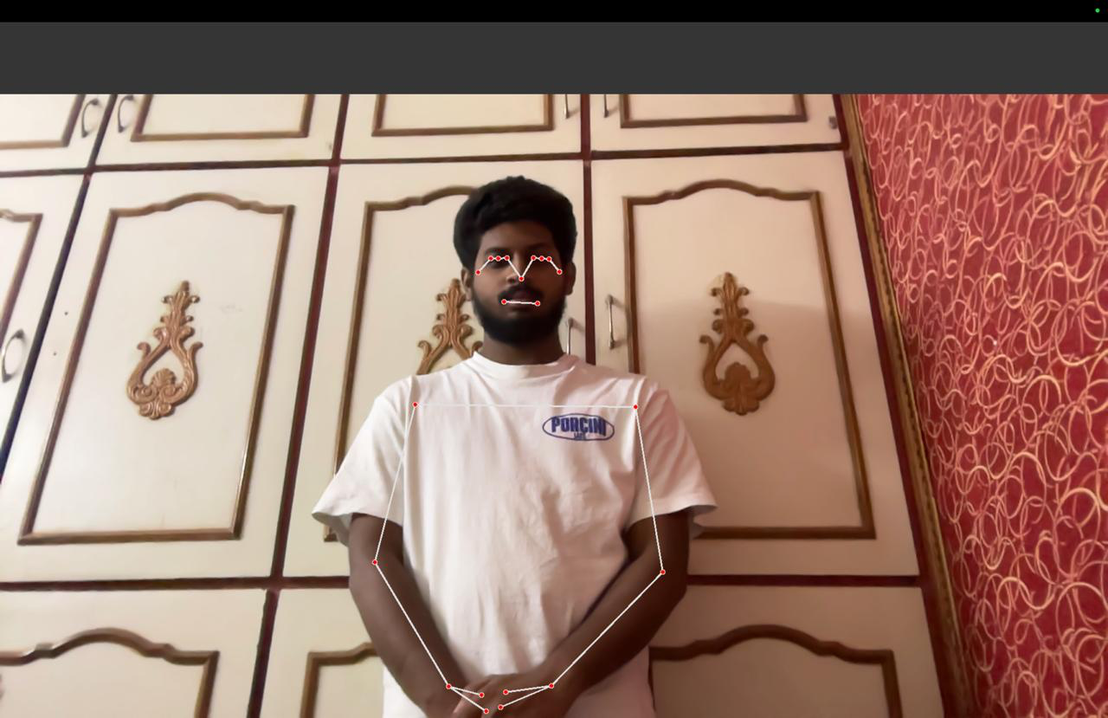

Platforms Used
- Google Colab
- GitHub
- Visual Studio Code

Deliverables
- Pose detection improvements completed
- Research notes prepared
- AI testing screenshots attached

